Co-3 Assessment Tool-2

Q1 – Distribution Analysis Using ECDF and Q-Q Plot:
1A) Create an Empirical Cumulative Distribution Function (ECDF) for Salary
Aim
To create an ECDF and understand the cumulative distribution of employee salaries.
Explanation
An Empirical Cumulative Distribution Function (ECDF) shows the proportion of employees whose salary is less than or equal to a particular salary value.
The dataset contains 20 employees from four departments: IT, HR, Finance, and Marketing. The salaries range from 36,000 to 72,000.
R Code
salary <- c(42000,45000,48000,51000,55000,
38000,40000,42000,46000,50000,
47000,49000,52000,58000,65000,
36000,39000,43000,47000,72000)

plot(ecdf(salary),
main="ECDF of Employee Salary",
xlab="Salary",
ylab="Cumulative Proportion")
Output:
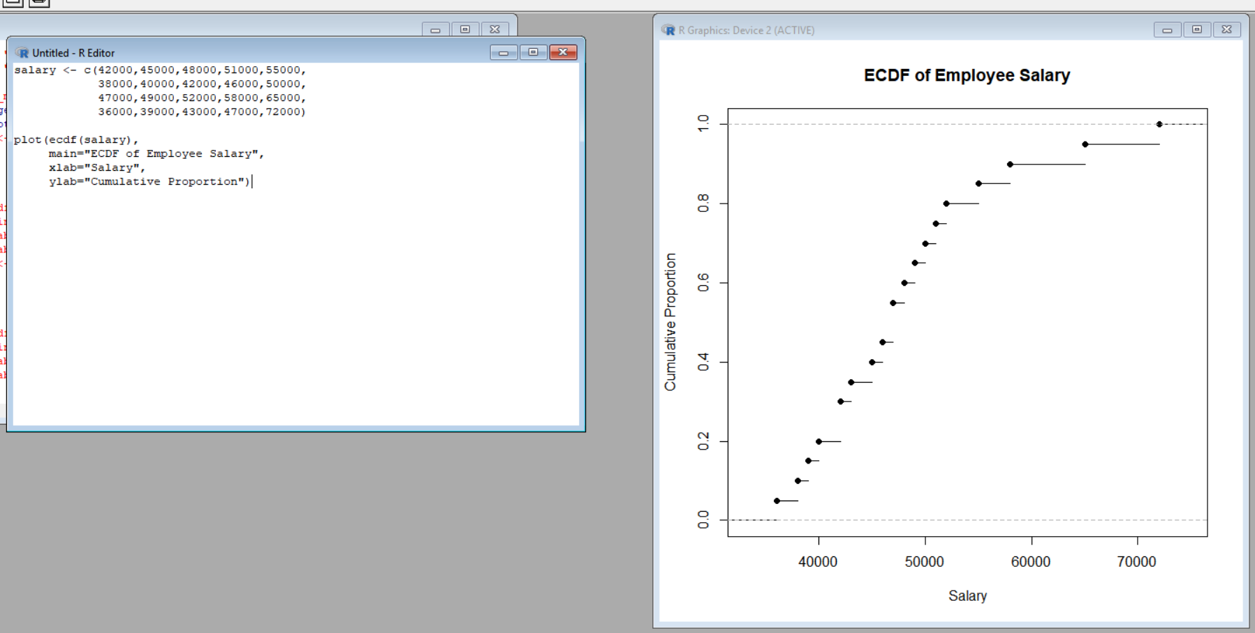
Interpretation
The ECDF starts from the lowest salary of 36,000 and gradually increases toward 1.
For example, when the cumulative proportion is around 0.50, approximately half of the employees have salaries below or equal to that salary level.
The graph provides a clear view of how employee salaries accumulate across the dataset.
Result
The ECDF successfully represents the cumulative distribution of employee salaries from 36,000 to 72,000.
1B) Create a Q-Q Plot for Salary
Aim
To use a Q-Q plot to determine whether employee salaries are approximately normally distributed.
Explanation
A Q-Q plot (Quantile-Quantile plot) compares the actual salary values with theoretical values from a normal distribution.
If the points are close to the reference line, the data is approximately normally distributed. If the points move away from the line, the data may not follow a normal distribution.
R Code
salary <- c(42000,45000,48000,51000,55000,
38000,40000,42000,46000,50000,
47000,49000,52000,58000,65000,
36000,39000,43000,47000,72000)

qqnorm(salary,
main="Q-Q Plot of Employee Salary")

qqline(salary)
Output:
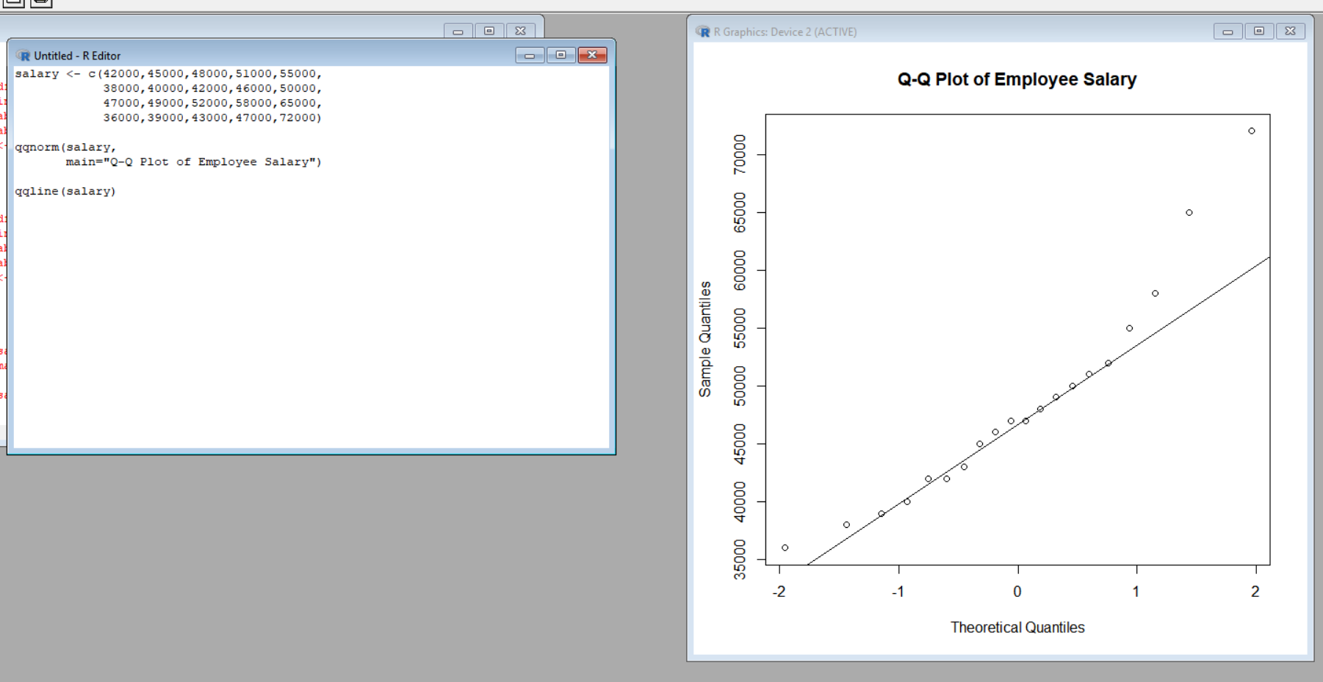
Interpretation
Most of the points in the middle region follow the reference line reasonably well.
However, some observations at the lower and upper ends move away from the line. The high salary of 72,000 contributes to the deviation in the upper tail.
Therefore, the salary distribution is not perfectly normal, although the central observations show a relatively regular pattern.
Result
The Q-Q plot indicates that employee salaries are approximately normal in the central region but show some deviation at the extreme values.
3C) Compare Salary Distributions of Four Departments
Aim
To compare the salary distributions of IT, HR, Finance, and Marketing.
Explanation
A boxplot is used to compare the salary distributions between departments.
A boxplot helps us observe:
- Median salary
- Spread of salaries
- Minimum and maximum values
- Possible unusual observations
The dataset contains five employees in each department.
R Code
dept <- c(rep("IT",5),
rep("HR",5),
rep("Finance",5),
rep("Marketing",5))

salary <- c(42000,45000,48000,51000,55000,
38000,40000,42000,46000,50000,
47000,49000,52000,58000,65000,
36000,39000,43000,47000,72000)

boxplot(salary ~ dept,
main="Salary Distribution by Department",
xlab="Department",
ylab="Salary")
Output:
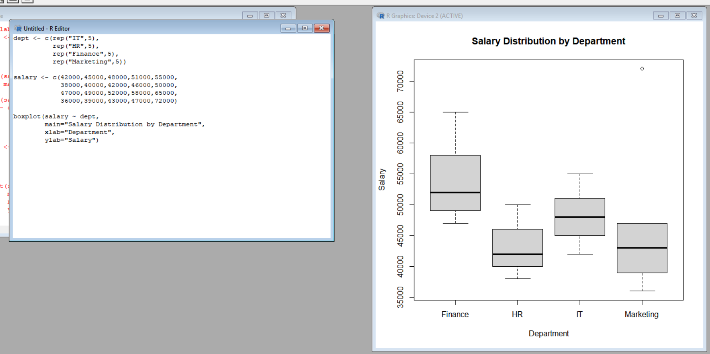
Interpretation
The boxplot shows differences between the four departments.
IT: Salaries range from 42,000 to 55,000, showing a moderate salary range.
HR: Salaries range from 38,000 to 50,000, making HR one of the lower salary groups.
Finance: Salaries range from 47,000 to 65,000, showing comparatively higher salaries.
Marketing: Salaries range from 36,000 to 72,000, giving Marketing the widest salary range.
The 72,000 salary makes the Marketing distribution particularly wide.
Result
The boxplot shows that Finance and Marketing have higher salary observations, while HR has relatively lower salaries. Marketing has the largest salary range.
1D) Identify Skewness and Unusual Observations
Aim
To identify possible skewness and unusual observations in the salary data.
Explanation
Skewness describes the asymmetry of a distribution.
A distribution with a longer right tail is called positively skewed. A distribution with a longer left tail is called negatively skewed.
The dataset contains a maximum salary of 72,000, which is noticeably higher than most other salary values. Therefore, it may be considered an unusual observation.
R Code
salary <- c(42000,45000,48000,51000,55000,
38000,40000,42000,46000,50000,
47000,49000,52000,58000,65000,
36000,39000,43000,47000,72000)

boxplot(salary,
main="Overall Salary Distribution",
ylab="Salary")

mean(salary)
median(salary)
Output:
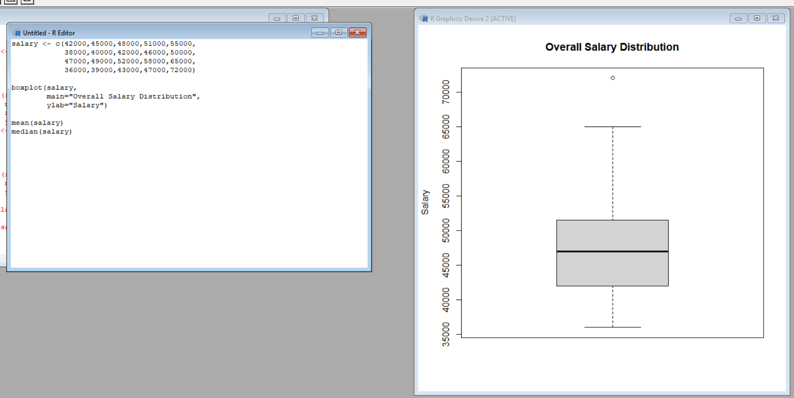
Interpretation
The boxplot shows that most salaries are concentrated between approximately 38,000 and 65,000.
The 72,000 salary is much higher than most observations and can be treated as a possible unusual observation.
The mean salary is slightly higher than the median salary, which indicates some positive/right skewness in the distribution.
The lower value of 36,000 is the minimum salary, but it is not as extreme as the 72,000 observation.
Result
The salary distribution shows some positive skewness, mainly because of the high salary observation of 72,000.
Q2 – Visualizing Many Distributions Using Bean Plots:
2A) Visualize Score Distribution for All Four Courses
Aim
To visualize the score distributions of all four courses at the same time.
Explanation
The dataset contains student scores for four courses:
- Python
- Statistics
- DataViz
- MachineLearning
Each course contains five students. The scores can be compared using a simple boxplot.
A boxplot helps us understand the center and spread of scores for each course.
R Code
course <- c(rep("Python",5),
rep("Statistics",5),
rep("DataViz",5),
rep("MachineLearning",5))

score <- c(62,68,74,81,88,
58,64,71,79,86,
55,61,69,77,84,
65,72,78,87,93)

boxplot(score ~ course,
main="Score Distribution by Course",
xlab="Course",
ylab="Score")
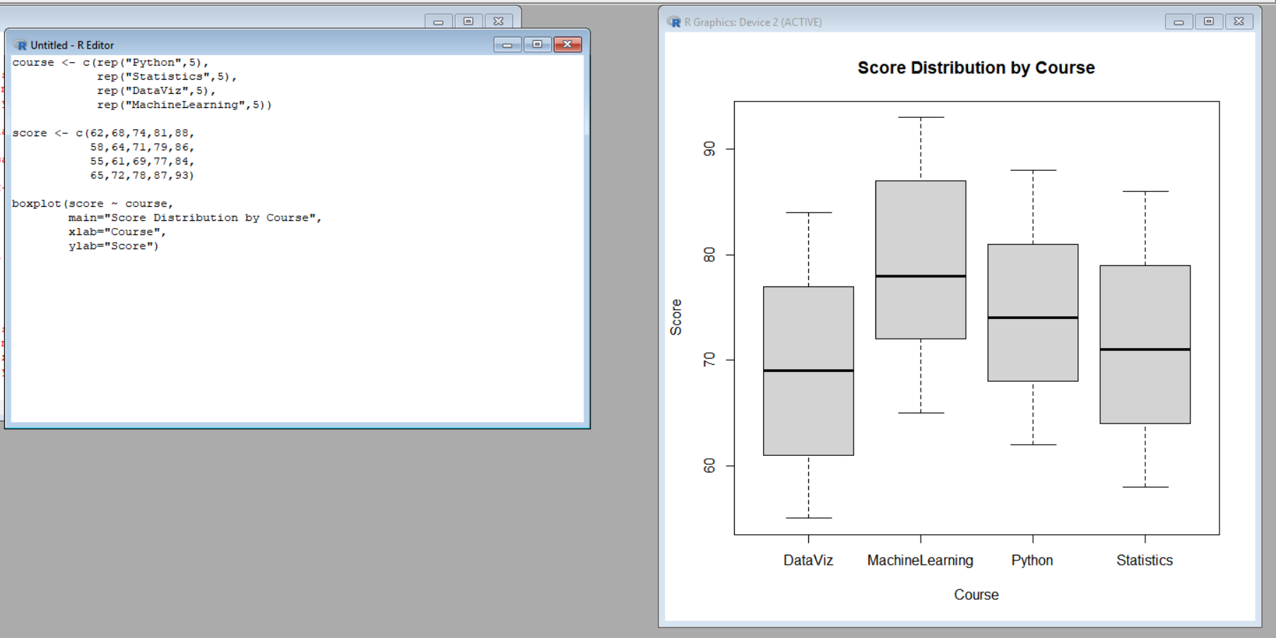
Interpretation
The boxplot shows the score distribution of all four courses.
Python scores range from 62 to 88.
Statistics scores range from 58 to 86.
DataViz scores range from 55 to 84.
MachineLearning scores range from 65 to 93.
MachineLearning has the highest scores overall, while DataViz has the lowest score range.
Result
The boxplot provides a simple comparison of student scores across all four courses.

2B) Create Bean Plots / Equivalent Violin Plot
Aim
To create a distribution-based visualization for comparing the score distributions of the four courses.
Explanation
A bean plot displays the distribution of numerical data for different groups.
If a bean-plot package is unavailable, a violin plot can be used as an equivalent visualization. A violin plot combines information about the distribution and its spread.
For this question, a simple violin plot can be created using ggplot2.
R Code
library(ggplot2)

data <- data.frame(
Course = c(rep("Python",5),
rep("Statistics",5),
rep("DataViz",5),
rep("MachineLearning",5)),
Score = c(62,68,74,81,88,
58,64,71,79,86,
55,61,69,77,84,
65,72,78,87,93)
)

ggplot(data, aes(Course, Score)) +
geom_violin() +
labs(title="Score Distribution by Course",
x="Course",
y="Score")
Output:
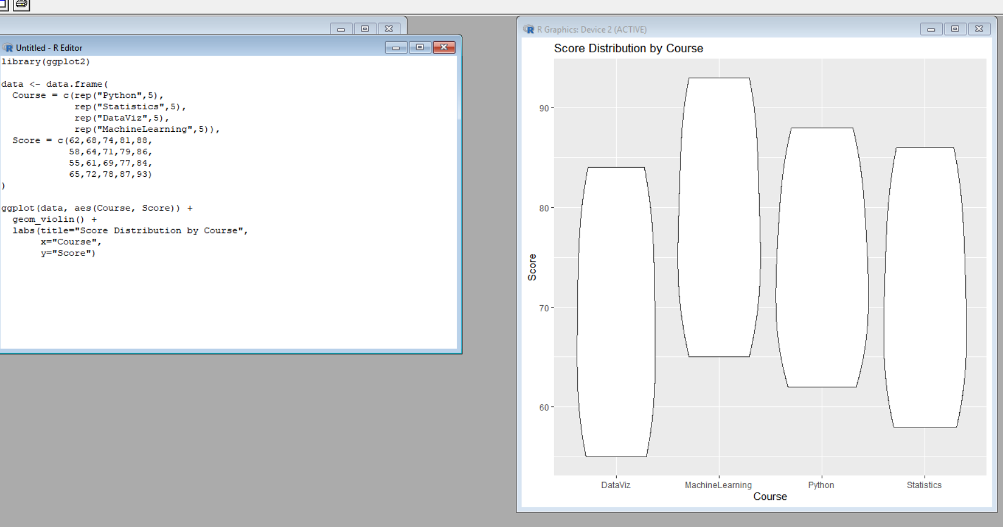
Interpretation
The violin plot shows the shape and spread of scores for each course.
MachineLearning has scores concentrated at the higher end.
DataViz has comparatively lower scores.
Python and Statistics occupy the middle range.
The width of the violin represents the concentration of observations at different score levels.
Result
The violin plot provides a better view of the shape and distribution of scores compared with a simple boxplot.
2C) Create a Vertical Distribution Visualization
Aim
To arrange the course distributions along the vertical axis and compare their score distributions.
Explanation
A second visualization helps compare the distributions from another orientation.
The courses can be placed on the vertical axis while scores are shown on the horizontal axis. This makes it easier to compare the score ranges between courses.
R Code
library(ggplot2)

ggplot(data, aes(Score, Course)) +
geom_violin() +
labs(title="Vertical Score Distributions",
x="Score",
y="Course")
Output;
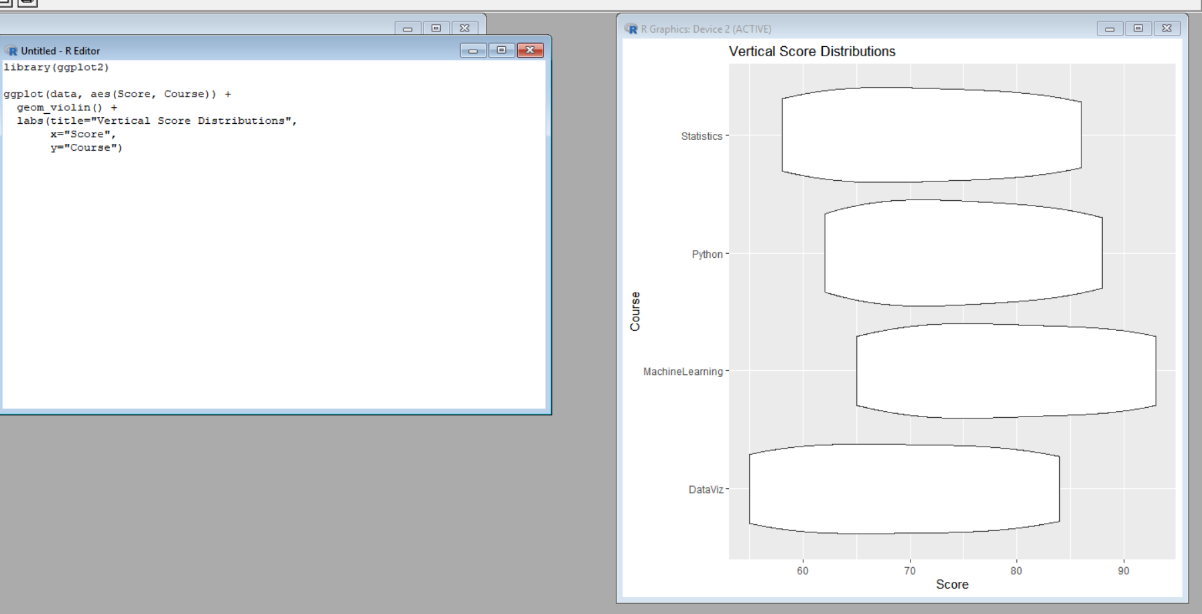
Interpretation
The vertical violin plot presents the same score distributions in a horizontal orientation.
MachineLearning extends toward the highest score of 93.
DataViz starts at the lowest score of 55.
Python and Statistics fall between these two courses.
This visualization makes it easy to observe the overall score range of each course.
Result
The vertical visualization clearly shows the different score ranges and positions of the four courses.

2D) Compare Center, Spread, and Shape
Aim
To compare the center, spread, and shape of the four course distributions and identify the course with the highest and most consistent performance.
Explanation
The center represents the typical score of a course.
The spread represents how much the scores vary.
The shape represents how the observations are distributed across the score range.
From the given data:
Course | Minimum | Maximum | Approx. Mean
Python | 62 | 88 | 74.6
Statistics | 58 | 86 | 71.6
DataViz | 55 | 84 | 69.2
MachineLearning | 65 | 93 | 79.0
Interpretation
Python:
Python has a good average score of approximately 74.6 and a moderate spread.
Statistics:
Statistics has an average of approximately 71.6.
DataViz:
DataViz has the lowest average score of approximately 69.2.
MachineLearning:
MachineLearning has the highest average score of approximately 79.0.
The scores in MachineLearning range from 65 to 93. Although its range is slightly larger, its scores are consistently at a higher level.
Therefore, MachineLearning has the highest overall performance.
For consistency, the standard deviation can be used to compare variation. The course with the smaller standard deviation has more consistent scores.
Result
MachineLearning has the highest average performance, while DataViz has the lowest average performance.

Q3 – Comparing Proportions with Pie, Side-by-Side and Stacked Bars:
3A) Create a Pie Chart Showing Overall Purchase Proportion by Product
Aim
To show the overall proportion of purchases for Laptop, Phone, and Tablet using a pie chart.
Explanation
A pie chart represents data as parts of a whole. Each product is represented by a section of the circle.
The dataset contains four regions and three products:
- Laptop
- Phone
- Tablet
The purchase counts are given in the dataset.
R Code
product <- c("Laptop","Phone","Tablet")
count <- c(105,145,90)

pie(count,
labels=product,
main="Overall Purchase Proportion")
Output:
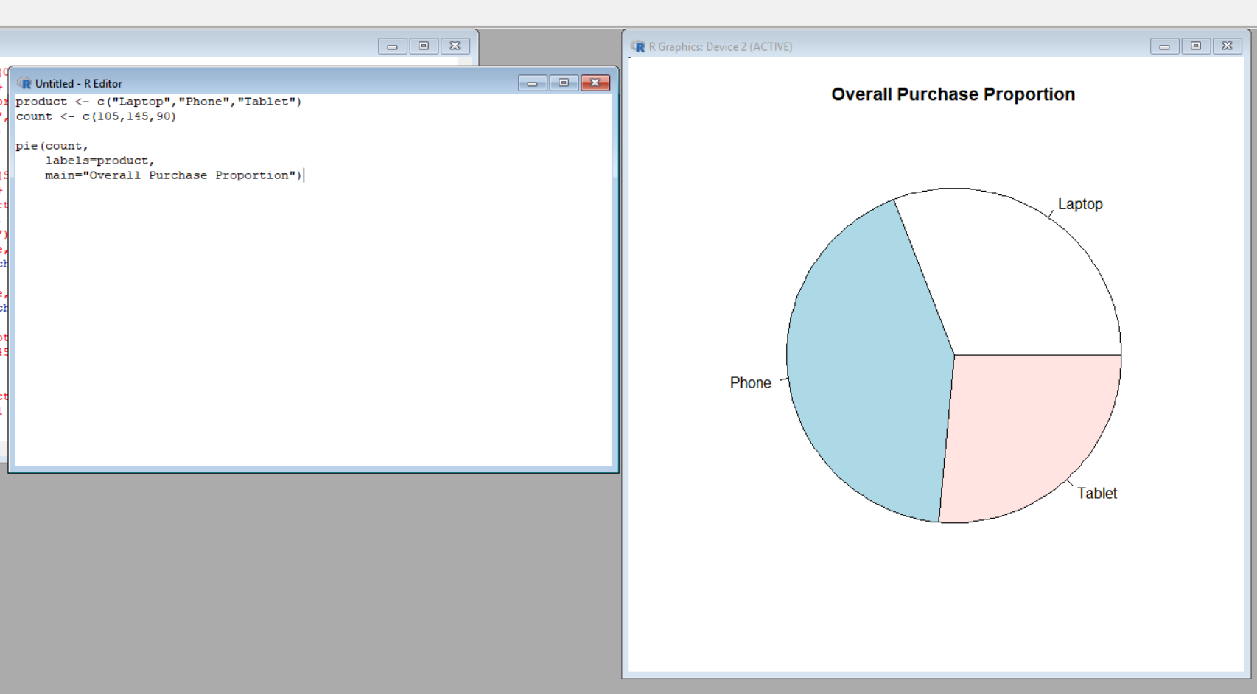
Interpretation
The pie chart shows that Phone has the largest number of purchases.
Laptop has fewer purchases than Phone, while Tablet has the lowest number of purchases.
Therefore, Phone represents the largest proportion of total purchases.
Result
The pie chart clearly shows that Phone is the most purchased product, while Tablet has the smallest proportion.
3B) Create Side-by-Side Bar Charts Across Regions
Aim
To compare product purchase counts across the four regions using a side-by-side bar chart.
Explanation
A side-by-side bar chart places the products next to each other for every region.
This makes it possible to compare:
- Laptop purchases
- Phone purchases
- Tablet purchases
across:
- North
- South
- East
- West
R Code
data <- matrix(c(
25,35,20,
30,40,25,
28,32,18,
22,38,27
), nrow=4, byrow=TRUE)

colnames(data) <- c("Laptop","Phone","Tablet")
rownames(data) <- c("North","South","East","West")

barplot(t(data),
beside=TRUE,
main="Product Purchases by Region",
xlab="Region",
ylab="Purchase Count",
Output:
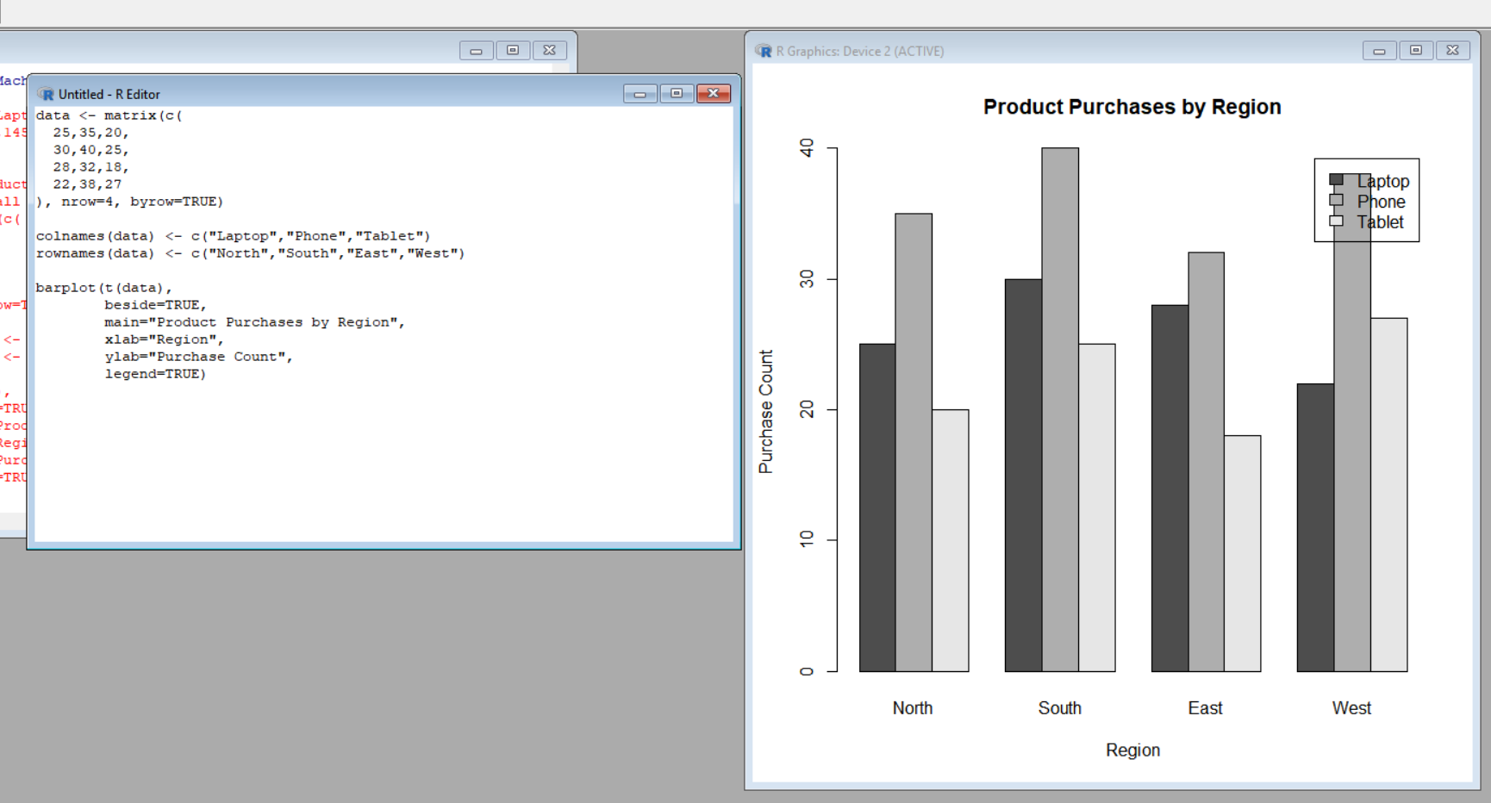
Interpretation
The side-by-side bar chart allows direct comparison of products within each region.
In the North, Phone has the highest purchase count.
In the South, Phone again has the highest count.
In the East, Phone has the highest count.
In the West, Phone also has the highest count.
Therefore, Phone is the leading product in every region.
Result
The side-by-side bar chart shows that Phone purchases are highest across all four regions.
3C) Create a Stacked Bar Chart
Aim
To show the composition of products within each region using a stacked bar chart.
Explanation
A stacked bar chart combines the product counts into one bar for each region.
Each bar represents the total purchases in a region, while different sections represent the individual products.
This allows us to see both:
- Total purchases
- Product composition
R Code
barplot(t(data),
beside=FALSE,
main="Stacked Product Purchases by Region",
xlab="Region",
ylab="Purchase Count",
legend=TRUE)
Output:
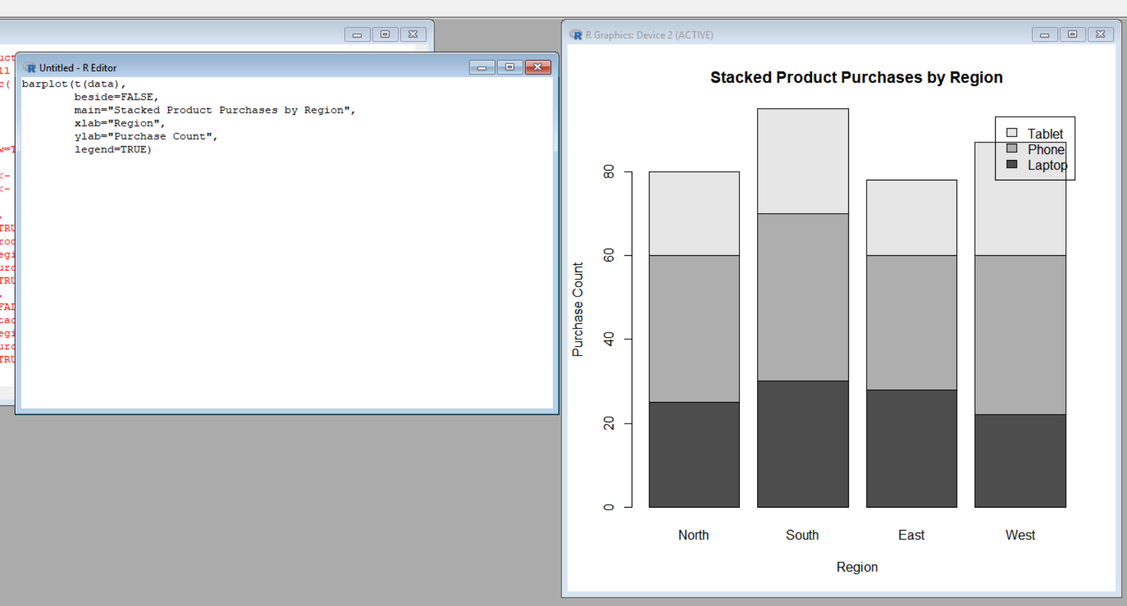
Interpretation
The stacked bar chart shows the total purchase count for each region.
The individual sections represent Laptop, Phone, and Tablet purchases.
The Phone section is generally the largest section in each region.
The chart also shows that the total purchase counts differ between regions.
Result
The stacked bar chart effectively shows the composition of product purchases within each region.

3D) Create a 100% Stacked Bar Chart
Aim
To compare the proportions of products within each region rather than their raw purchase counts.
Explanation
A normal stacked bar chart compares raw counts.
A 100% stacked bar chart converts each region into 100%. Therefore, every region has the same total bar height.
This allows us to compare the percentage contribution of Laptop, Phone, and Tablet within each region.
R Code
percent <- prop.table(data, 1) * 100

barplot(t(percent),
beside=FALSE,
main="100% Stacked Product Proportions",
xlab="Region",
ylab="Percentage",
legend=TRUE)
Output:
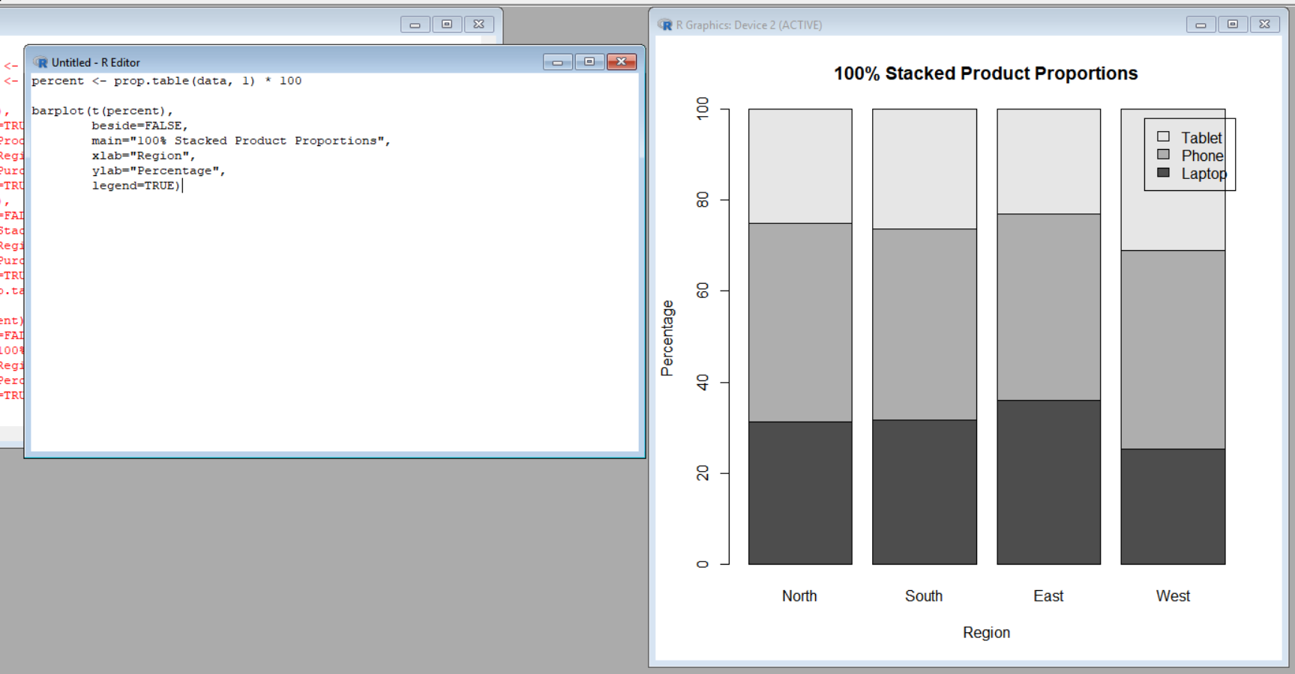
Interpretation
The 100% stacked bar chart allows direct comparison of product proportions between regions.
Although the total number of purchases differs between regions, every bar represents 100%.
Phone occupies the largest proportion in most regions.
This makes it easier to determine whether the product preferences are similar or different between regions.
Result
The 100% stacked bar chart provides a clearer comparison of regional product proportions than a normal stacked bar chart.

3E) Which Visualization Is More Appropriate for Comparing Regional Proportions?
Aim
To determine which visualization is most suitable for comparing product proportions across regions.
Explanation
Different charts provide different types of information.
A pie chart is useful for showing the overall proportion of products, but it becomes difficult to compare multiple regions.
A side-by-side bar chart is useful for comparing raw purchase counts directly.
A stacked bar chart shows both total purchases and product composition, but comparing the individual segments can be difficult.
A 100% stacked bar chart is most appropriate when the main purpose is to compare proportions between regions.
Interpretation
For comparing regional proportions, the 100% stacked bar chart is the most appropriate.
Every region is represented by a bar of equal height. Therefore, the percentage contribution of each product can be compared directly.
For example, even if one region has more total purchases than another, the 100% stacked chart allows us to compare their product preferences without the difference in total counts affecting the visual comparison.
Result
The 100% stacked bar chart is the most suitable visualization for comparing product proportions across regions.
Q4 – Nested Proportions Using Treemap and Sunburst Charts
4(a) Create a Treemap
Aim
To create a treemap showing the hierarchy Region → Category → Subcategory, where the size of each rectangle represents sales.
Explanation
A treemap represents hierarchical data using nested rectangles.
In this dataset, the hierarchy is:
Region → Category → Subcategory
The categories are:
- Electronics
  - Laptop
  - Phone
- Furniture
  - Chair
  - Desk
The size of each rectangle represents the amount of sales.
The dataset contains four regions: North, South, East, and West.
R Code
install.packages("treemap")
library(treemap)

data <- data.frame(
Region = c(rep("North",4), rep("South",4),
rep("East",4), rep("West",4)),
Category = rep(c("Electronics","Electronics",
"Furniture","Furniture"),4),
Subcategory = rep(c("Laptop","Phone","Chair","Desk"),4),
Sales = c(52000,38000,22000,18000,
46000,42000,25000,21000,
58000,35000,19000,23000,
49000,44000,27000,20000)
)

treemap(data,
index=c("Region","Category","Subcategory"),
vSize="Sales",
title="Company Sales Treemap")
Output:
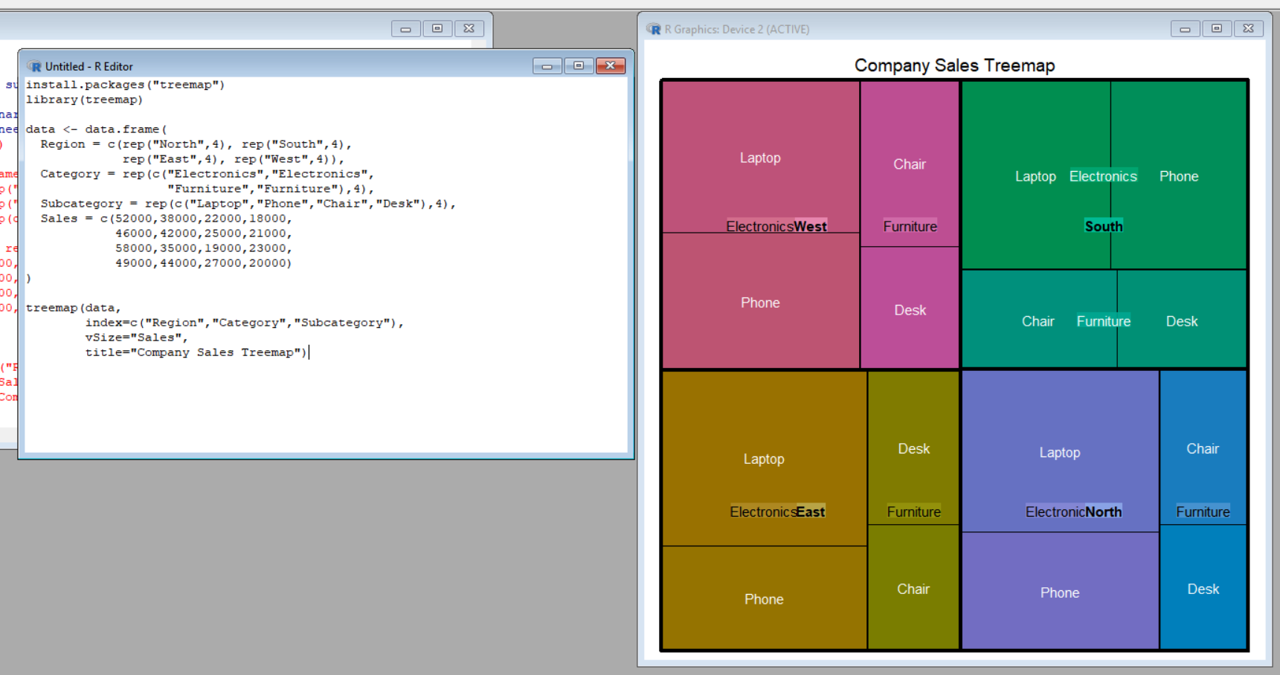
Interpretation
The treemap displays sales using different rectangle sizes.
Larger rectangles represent higher sales.
The hierarchy can be followed from:
Region → Category → Subcategory
The Electronics category occupies a larger area than Furniture in every region because Laptop and Phone generate higher sales.
Result
The treemap successfully represents the company's nested sales structure, with rectangle size representing sales.

4(b) Create a Sunburst Chart
Aim
To create a sunburst chart representing the same Region → Category → Subcategory hierarchy.
Explanation
A sunburst chart represents hierarchical data using concentric rings.
The inner ring represents the higher-level category, while the outer rings represent lower-level categories.
For this dataset:
- Inner level → Region
- Middle level → Category
- Outer level → Subcategory
The size of each section represents sales.
R Code
install.packages("plotly")
library(plotly)

region <- c("North","North","North","North",
"South","South","South","South",
"East","East","East","East",
"West","West","West","West")

category <- c("Electronics","Electronics","Furniture","Furniture",
"Electronics","Electronics","Furniture","Furniture",
"Electronics","Electronics","Furniture","Furniture",
"Electronics","Electronics","Furniture","Furniture")

subcategory <- c("Laptop","Phone","Chair","Desk",
"Laptop","Phone","Chair","Desk",
"Laptop","Phone","Chair","Desk",
"Laptop","Phone","Chair","Desk")

sales <- c(52000,38000,22000,18000,
46000,42000,25000,21000,
58000,35000,19000,23000,
49000,44000,27000,20000)

data <- data.frame(region, category, subcategory, sales)

plot_ly(
labels = data$subcategory,
parents = data$category,
values = data$sales,
type = "sunburst"
)
Output:
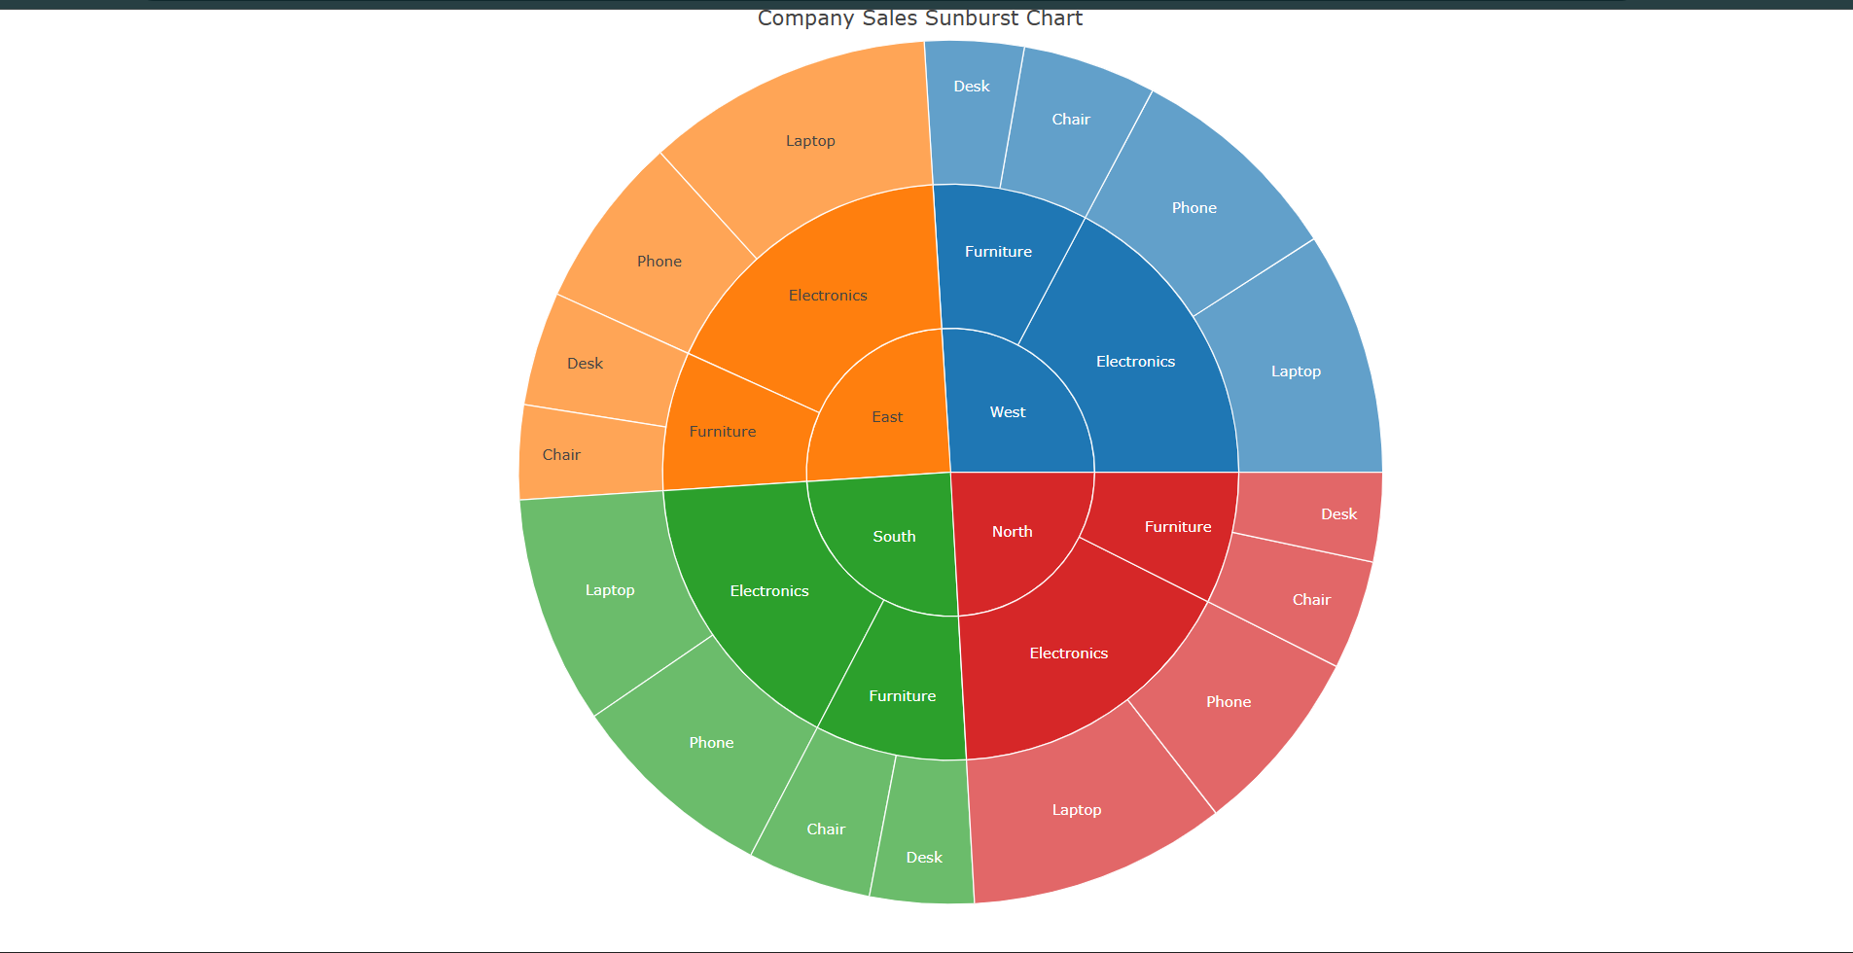

Interpretation
The sunburst chart represents the sales hierarchy using circular layers.
The inner sections represent the higher-level groups, while the outer sections represent the subcategories.
Larger sections indicate higher sales.
This makes it possible to understand how sales are distributed through different levels of the hierarchy.
Result
The sunburst chart successfully represents the nested sales structure using concentric levels.

4(c) Identify the Largest Region, Category and Subcategory
Aim
To identify which region, category, and subcategory have the highest sales.
Explanation
The sales values can be grouped and added to determine the largest values at each hierarchical level.
R Code
# Q4(c) - Sales Comparison

region <- c("North","South","East","West")
region_sales <- c(130000,134000,135000,140000)

category <- c("Electronics","Furniture")
category_sales <- c(364000,175000)

subcategory <- c("Laptop","Phone","Chair","Desk")
subcategory_sales <- c(205000,159000,93000,82000)

par(mfrow=c(1,3))

barplot(region_sales,
names.arg=region,
main="Sales by Region",
ylab="Sales")

barplot(category_sales,
names.arg=category,
main="Sales by Category",
ylab="Sales")

barplot(subcategory_sales,
names.arg=subcategory,
main="Sales by Subcategory",
ylab="Sales")

par(mfrow=c(1,1))
Output:
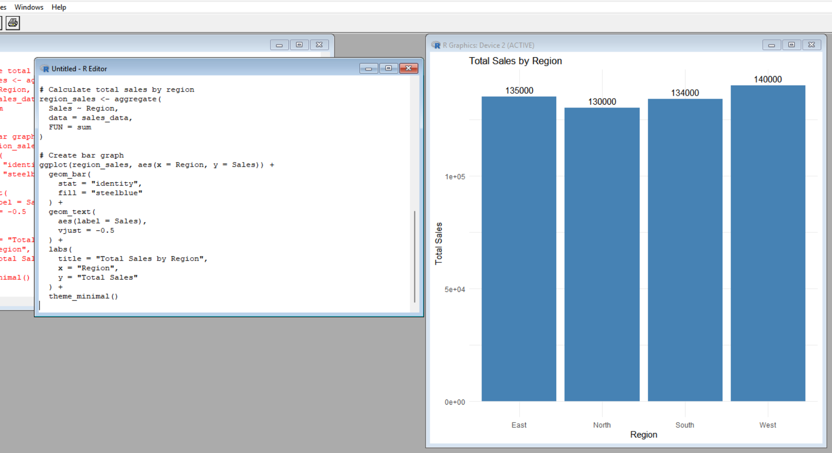
Interpretation
The West region has the highest total sales of 140,000.
The Electronics category is the largest category with total sales of 364,000.
Among the subcategories, Laptop has the highest sales with 205,000.
Result
- Largest Region: West
- Largest Category: Electronics
- Largest Subcategory: Laptop

4D) Compare Treemap and Sunburst Readability
Aim
To compare the readability of the treemap and sunburst chart for identifying nested proportions.
Explanation
Both visualizations represent the same hierarchical data, but they use different structures.
A treemap uses rectangles.
A sunburst chart uses circular rings.
Treemap
The treemap makes it easy to compare the size of sales values because rectangles can be compared directly by their area.
It is particularly useful when the main purpose is to identify the largest sales categories.
Sunburst
The sunburst chart makes the hierarchical relationship visually clear.
The different rings show the levels of the hierarchy:
Region → Category → Subcategory
However, comparing the sizes of curved sections can be more difficult than comparing rectangular areas.
Interpretation
For comparing sales values, the treemap is generally easier to read.
For understanding the hierarchical structure, the sunburst chart provides a clear visual representation.
Result
The treemap is better for comparing sales sizes, while the sunburst chart is useful for understanding the hierarchy.

4E) Limitations of Treemap and Sunburst
Aim
To identify one potential limitation of each visualization.
Treemap Limitation
A treemap can become difficult to read when there are many categories or very small rectangles.
Small sections may not have enough space for labels.
Sunburst Limitation
A sunburst chart can become difficult to interpret when there are many hierarchical levels or small segments.
Comparing the areas of curved sections is also more difficult than comparing rectangular areas.
Interpretation
The treemap is easier to compare by area but may become crowded with many categories.
The sunburst provides a strong hierarchy view but can become difficult to compare when many small segments are present.
Q5 – Flow-Based Proportions with Sankey Diagram and Parallel Sets
5A) Sankey Diagram
Aim
To create a Sankey diagram showing the flow:
Specialization → Internship → Placement Sector
where the width of each flow represents the number of students.
Explanation
A Sankey diagram is used to visualize flows between different categories.
In this question, the flow starts from the student's specialization, moves to internship status, and finally reaches the placement sector.
The dataset contains four specializations:
- Data Analytics
- AI
- Cyber Security
- Cloud Computing
The internship status is Yes/No, and placement sectors include IT, Finance, Healthcare, and Government.
R Code
install.packages("networkD3")
library(networkD3)

nodes <- data.frame(name=c(
"Data Analytics","AI","Cyber Security","Cloud Computing",
"Internship Yes","Internship No",
"IT","Finance","Healthcare","Government"
))

links <- data.frame(
source=c(0,1,2,3,0,1,2,3,4,4,4,5,5),
target=c(4,4,4,4,5,5,5,5,6,7,8,6,9),
value=c(30,30,25,23,8,6,7,5,69,29,10,14,12)
)

sankeyNetwork(
Links=links,
Nodes=nodes,
Source="source",
Target="target",
Value="value",
NodeID="name",
fontSize=12,
nodeWidth=20
)
OUTPUT:
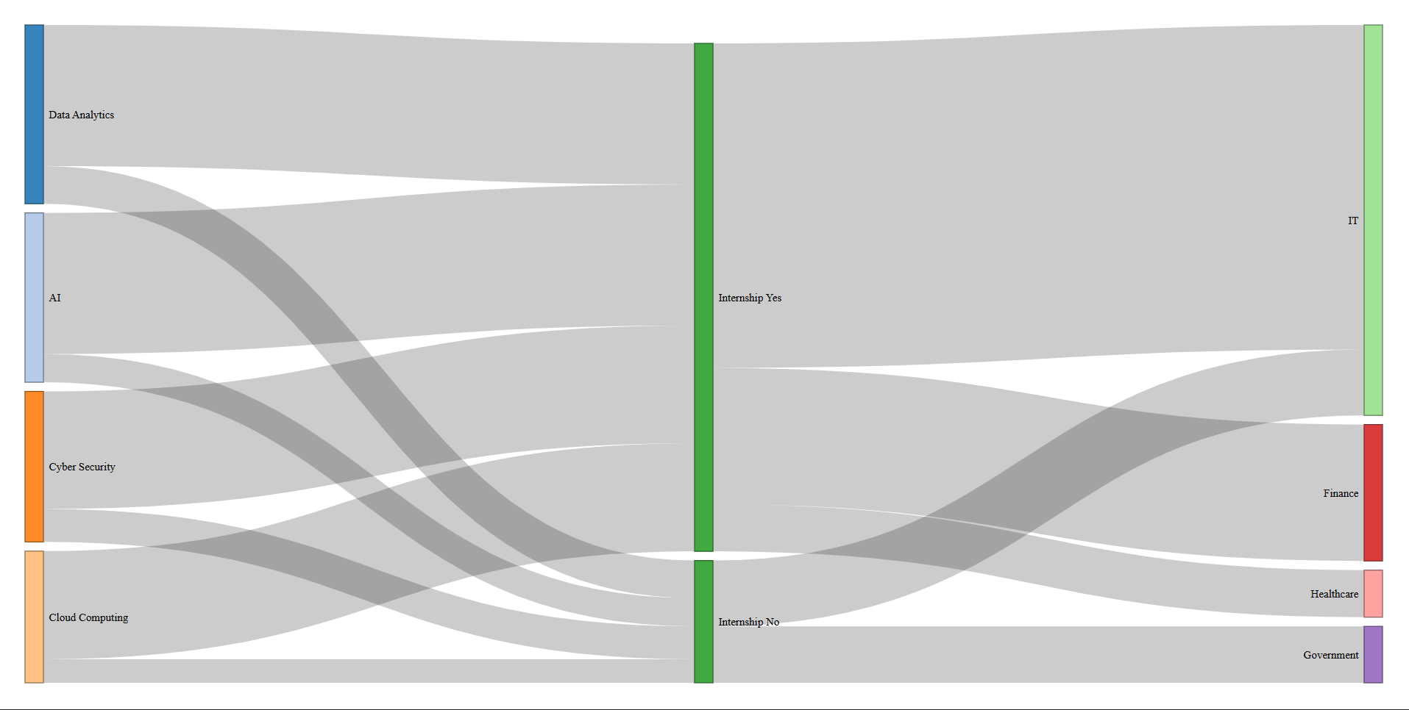
Graph Output
The graph will show:
Specialization → Internship → Placement Sector
The thicker the flow, the greater the number of students.
Interpretation
The largest specialization-to-internship flows are:
- Data Analytics → Yes = 30 students
- AI → Yes = 30 students
- Cyber Security → Yes = 25 students
- Cloud Computing → Yes = 23 students
Among students with internships, the largest flow is:
Internship Yes → IT = 69 students
Result
The Sankey diagram clearly shows that students with internships have a strong flow toward the IT sector.
5B) Parallel Sets Visualization
Aim
To create a parallel sets visualization showing the relationship between specialization, internship status, and placement sector.
Explanation
A parallel sets chart displays categorical relationships using connected bands.
It allows us to follow the students through:
Specialization → Internship → Placement Sector
The thickness of the bands represents the number of students.
R Code
install.packages("ggalluvial")
library(ggplot2)
library(ggalluvial)

data <- data.frame(
Specialization=c(
"Data Analytics","Data Analytics","Data Analytics",
"AI","AI","AI",
"Cyber Security","Cyber Security","Cyber Security",
"Cloud Computing","Cloud Computing","Cloud Computing"
),
Internship=c(
"Yes","Yes","No",
"Yes","Yes","No",
"Yes","Yes","No",
"Yes","Yes","No"
),
Placement=c(
"IT","Finance","IT",
"IT","Healthcare","IT",
"IT","Finance","Government",
"IT","Finance","Government"
),
Students=c(18,12,8,20,10,6,16,9,7,15,8,5)
)

ggplot(data,
aes(axis1=Specialization,
axis2=Internship,
axis3=Placement,
y=Students)) +
geom_alluvium(aes(fill=Internship)) +
geom_stratum() +
geom_text(stat="stratum",
aes(label=after_stat(stratum))) +
labs(title="Student Career Paths",
y="Students")
Output:
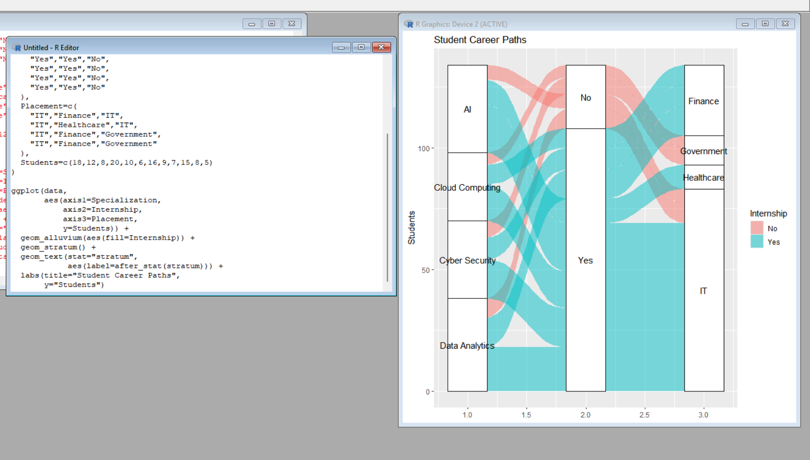
Graph Output
The graph displays three vertical stages:
Specialization → Internship → Placement
The width of each flow represents the number of students.
Interpretation
The parallel sets visualization shows how students move from their specialization to internship status and then to placement sectors.
The largest visible flow is toward the IT sector.
Students with internships show stronger flows toward IT and Finance, while students without internships mainly flow toward IT and Government.
Result
The parallel sets chart provides a clear view of the relationships between specialization, internship status, and placement sector.
5C) Identify Major Flows and Compare Internship Patterns
Aim
To identify the major student flows and compare placement patterns between students with and without internships.
Explanation
A simple bar graph can be used to compare the number of students placed in different sectors according to internship status.
From the dataset:
Students with Internship
- IT = 69
- Finance = 29
- Healthcare = 10
Students without Internship
- IT = 14
- Government = 12
The dataset values are given in the assignment.
R Code
sector <- c("IT","Finance","Healthcare","IT","Government")
students <- c(69,29,10,14,12)

group <- c("Internship Yes","Internship Yes",
"Internship Yes","Internship No",
"Internship No")

barplot(students,
names.arg=sector,
main="Placement by Internship Status",
xlab="Placement Sector",
ylab="Students")
Output:
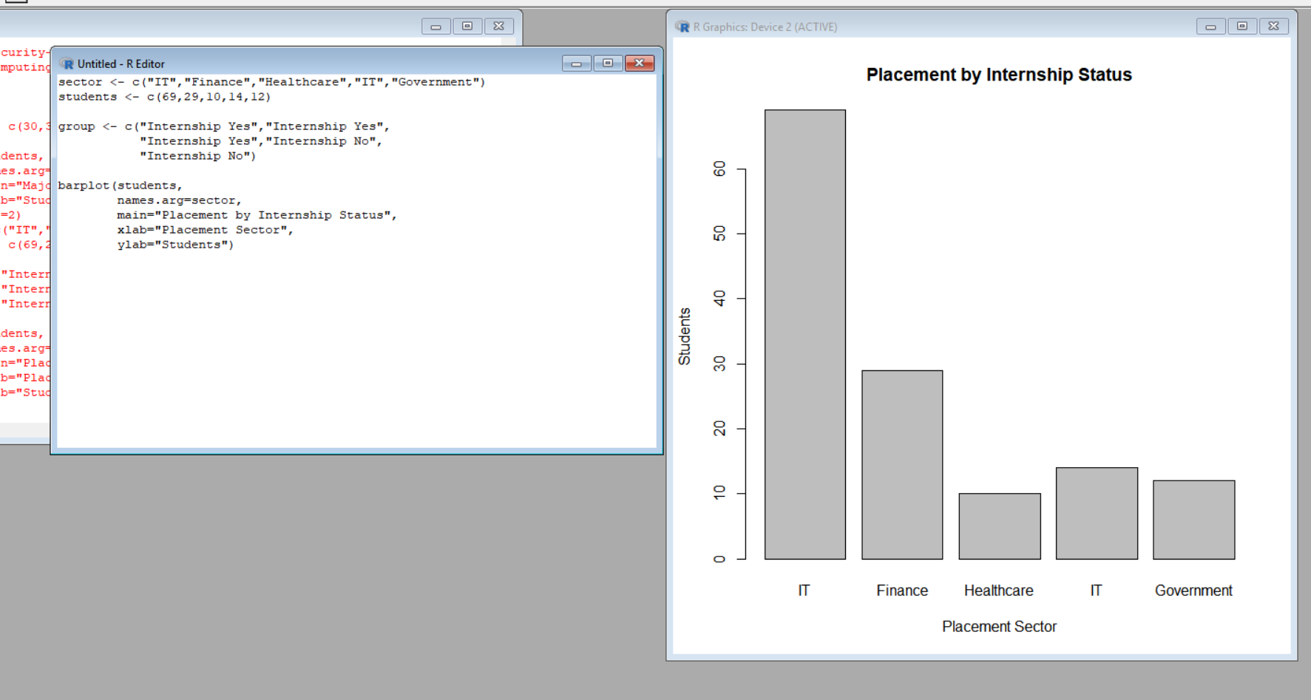
Graph Output
The bar graph compares the number of students in different placement sectors.
Interpretation
The graph shows that the largest flow is:
Internship Yes → IT = 69 students
The next major flow is:
Internship Yes → Finance = 29 students
For students without internships:
- IT = 14
- Government = 12
Therefore, students with internships have a stronger placement flow toward IT and Finance.
Result
The Internship Yes → IT flow is the largest flow in the dataset, with 69 students.

5D) Compare Which Visualization Communicates the Flow More Clearly
Aim
To determine whether the Sankey diagram or parallel sets visualization communicates the student flow more clearly.
Explanation
Both visualizations represent the same categorical relationships, but they have different strengths.
A Sankey diagram emphasizes the amount of flow between categories. Wider bands represent larger numbers of students.
A parallel sets chart emphasizes relationships between multiple categorical variables and allows several categorical dimensions to be viewed together.
R Code – Graph Output
To make this comparison visual, we can create a simple bar chart showing the major flows.
flow <- c(
"Data Analytics-Yes",
"AI-Yes",
"Cyber Security-Yes",
"Cloud Computing-Yes",
"Yes-IT"
)

students <- c(30,30,25,23,69)

barplot(students,
names.arg=flow,
main="Major Student Flows",
ylab="Students",
las=2)
Output:
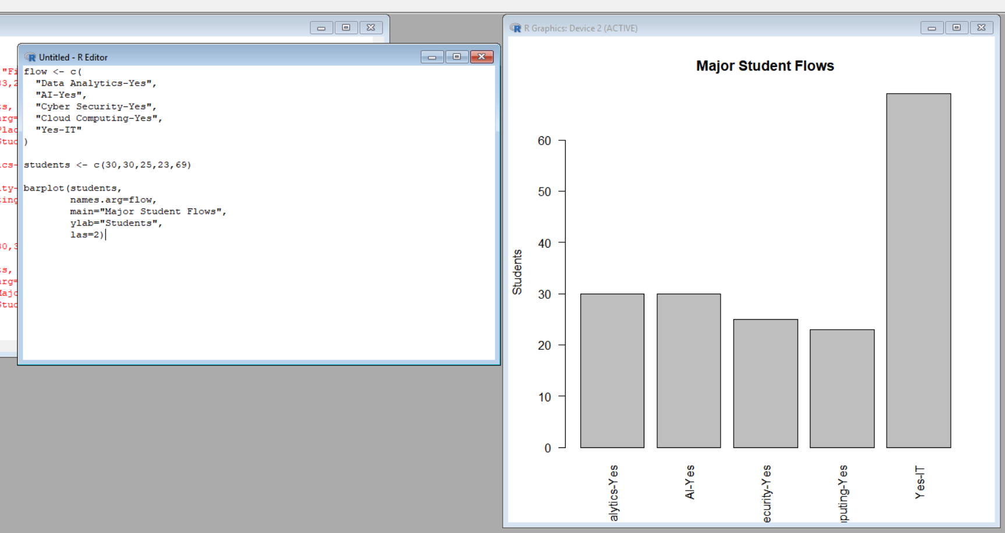
Graph Output
The graph compares the major student flows based on the number of students.
Interpretation
The Sankey diagram is more effective for showing the actual flow structure because the width of the bands directly represents the number of students moving between stages.
The parallel sets chart is useful for viewing multiple categorical relationships at the same time.
For this particular dataset, the Sankey diagram communicates the major flows more clearly because the main purpose is to understand how students move from one stage to another.
Result
The Sankey diagram is the clearer visualization for communicating student flows, while parallel sets is useful for examining categorical relationships.

5E) How Can the Chart Become Misleading?
Aim
To identify ways in which the visualization could become misleading.
Explanation
A flow visualization can give an incorrect impression if the visual scale does not represent the actual number of students correctly.
Some common problems include:
- Incorrect flow widths
- Misleading colors
- Missing labels
- Inconsistent scales
- Very similar colors for different categories
For example, if a small flow is displayed with the same width as a large flow, the viewer may think both flows contain similar numbers of students.
R Code – Graph Output
flow <- c("IT","Finance","Healthcare","Government")
students <- c(83,29,10,12)

barplot(students,
names.arg=flow,
main="Placement Sector Comparison",
ylab="Students")
Output:
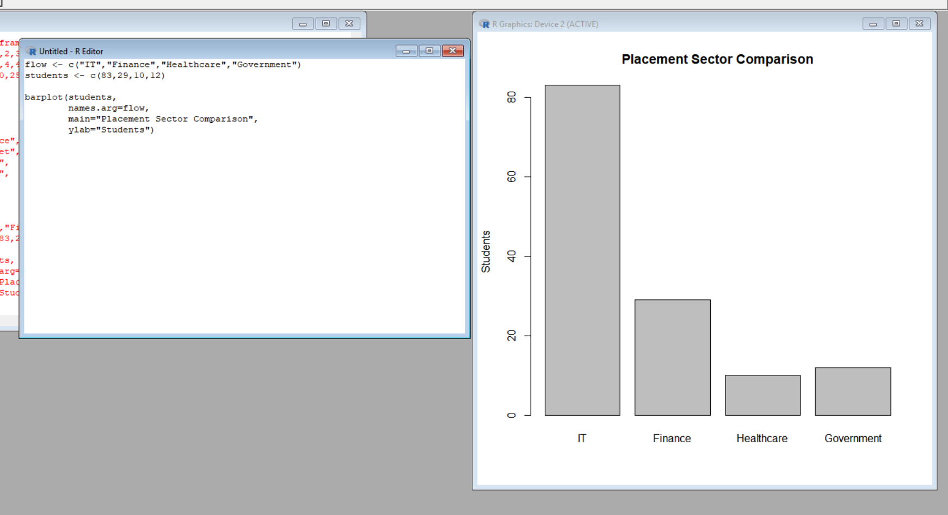
Graph Output
The graph shows the difference in the number of students across placement sectors.
Interpretation
The graph shows that IT has the largest number of students.
If the scale were changed improperly or the y-axis were labelled incorrectly, the difference between IT and the other sectors could be exaggerated or hidden.
Similarly, using misleading colors or unclear labels could make the viewer misunderstand the actual flow.
Result
Charts should use correct scales, meaningful labels, and consistent visual encodings to avoid misleading conclusions.

